Multi-Factor Driver
Authentication System
Complete Technical Report
Phases 1 – 5
Face Detection · Fingerprint · Relay & Ignition · GSM/SMS · Integration
📷 Full Assembled System Photo
Add screenshot / photo here

Table of Contents

Executive Summary
This report consolidates the full technical documentation of the Multi-Factor Driver Authentication System — a Raspberry Pi-based unit that secures a vehicle's ignition behind two biometric factors and is fully operable by SMS. The work is organised into five phases, each delivering an independently testable subsystem:
- Phase 1 — Face Detection: Haar detection, multi-pose registration, LBPH recognition, and auto-lighting.
- Phase 2 — Fingerprint Authentication: R307S enrollment, verification, and the dual-factor decision.
- Phase 3 — Relay & Ignition Control: 3-channel relay, timer-latch power hold, and ignition gating.
- Phase 4 — GSM/SMS Remote Control: SIM800 command/alert layer over the cellular network.
- Phase 5 — System Integration & Deployment: the Main.py state machine, kiosk UI, and lifecycle.

Each part below corresponds to one phase. Phase 1 includes the captured screenshots; remaining placeholders are provided for additional photos.
Phase 1

Face Detection

1. Overview
Phase 1 implements the core computer-vision pipeline: face detection, driver registration, real-time face recognition, and automatic LED lighting control. It is software-only and runs on a standard PC or Raspberry Pi with an attached camera.

1.1 Key Features
- Strict Haar Cascade face detection (centre-zone only, high confidence)
- iPhone-style multi-pose registration — 5 poses × 2 lighting × 20 samples = 200 samples
- LBPH face recognizer; multiple-face alert; debounced LED control; CSV logging

2. System Architecture
Module | Responsibility
Face Detection | Centre-zone Haar detection (minNeighbors=8, minSize=100×100).
Registration | 5 poses × 2 lighting × 20 frames; trains LBPH.
Authentication | Compares live ROI to the LBPH model against a confidence threshold.
LED Controller | Central-ROI brightness with a debounced relay.
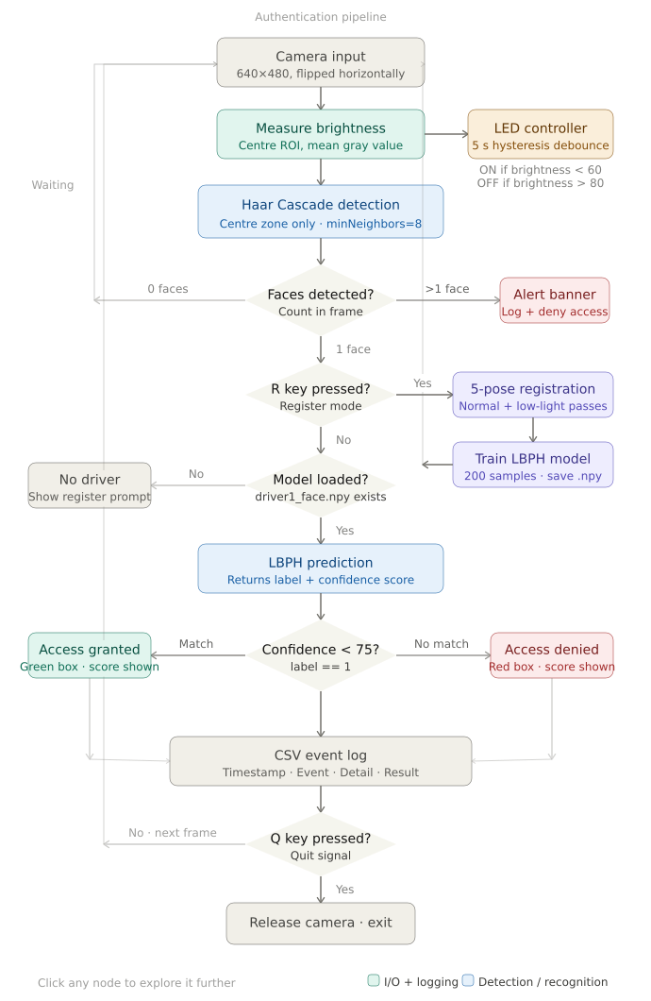
System flow diagram — the full authentication pipeline

3. Face Detection
Constant | Value | Description
DETECT_SCALE | 1.1 | Image-pyramid scale factor
DETECT_MIN_NEIGHBORS | 8 | Higher = fewer false positives
DETECT_MIN_SIZE | (100, 100) | Minimum face size in pixels
DETECT_ZONE_X / Y | 80 / 60 px | Detection-zone edge insets
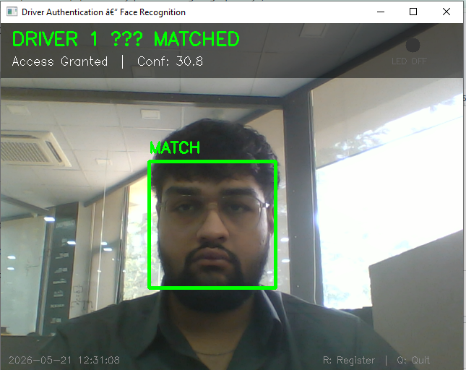  Single face — normal detection | 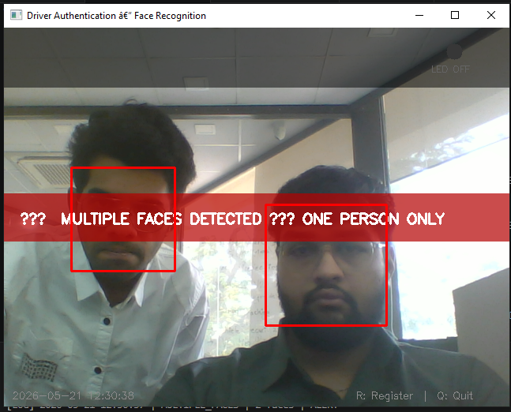  Multiple-face alert — access blocked
During registration, detection is relaxed (minNeighbors=4, minSize=60×60) to allow angled poses.

4. Driver Registration
Sample Count
5 poses × 2 lighting × 20 samples = 200 training samples stored in driver1_face.npy.

1 | Look straight at the camera  Baseline frontal view — normal + low light
2 | Turn head RIGHT / LEFT  Profile variations
3 | Tilt head UP / DOWN  Gaze variations
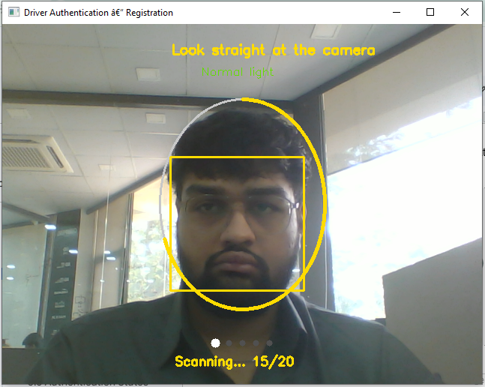  Step 1 — normal light | 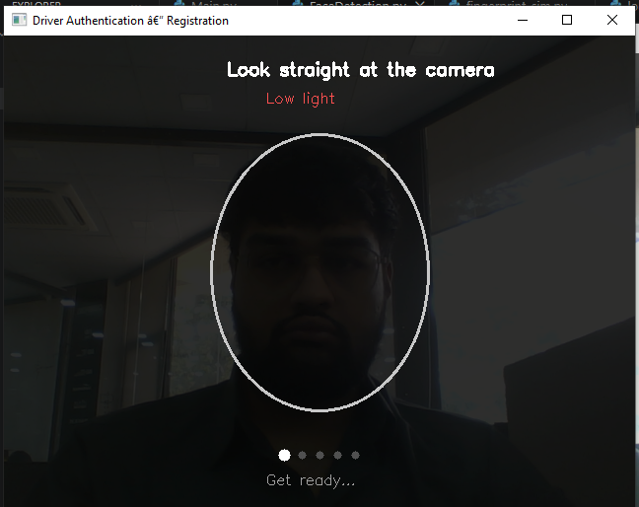  Step 1 — low light
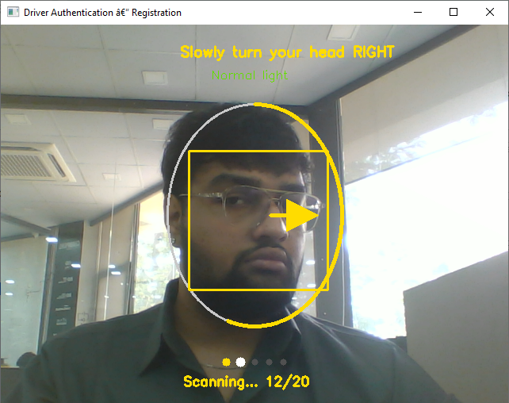  Step 2 — turn right | 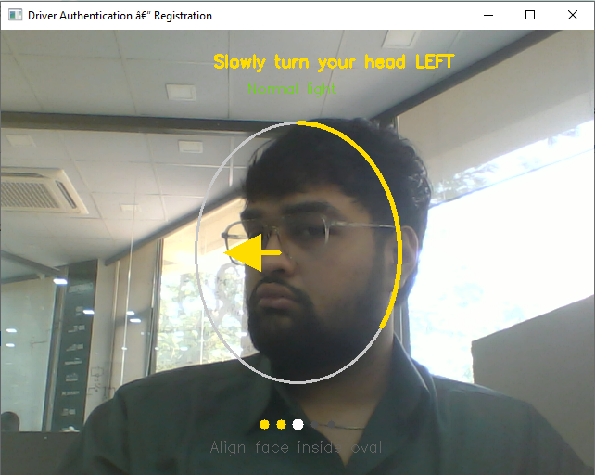  Step 3 — turn left
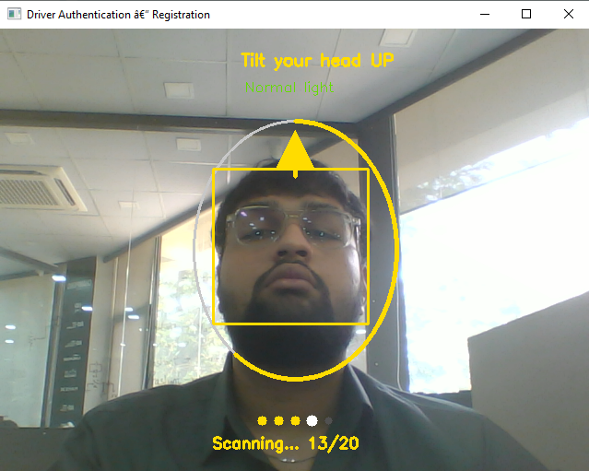  Step 4 — tilt up | 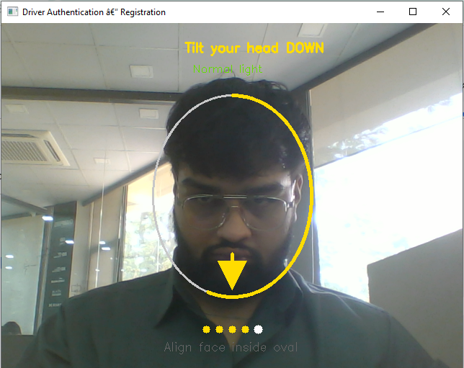  Step 5 — tilt down
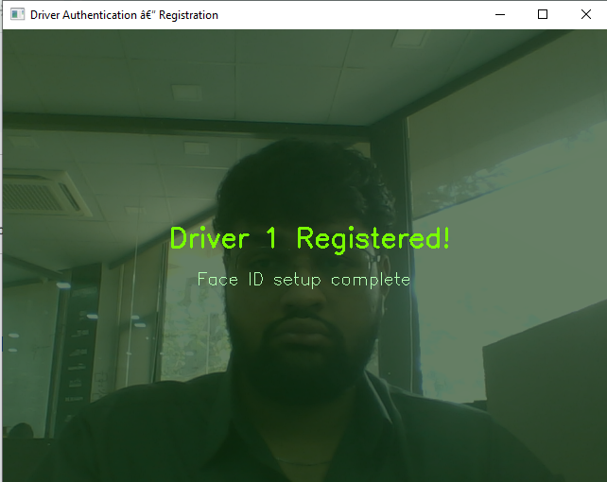
Registration complete — “Driver 1 Registered!”

5. Authentication
LBPH returns a confidence value; lower is a better match. MATCH_THRESHOLD = 75: granted if label == 1 and confidence < 75.
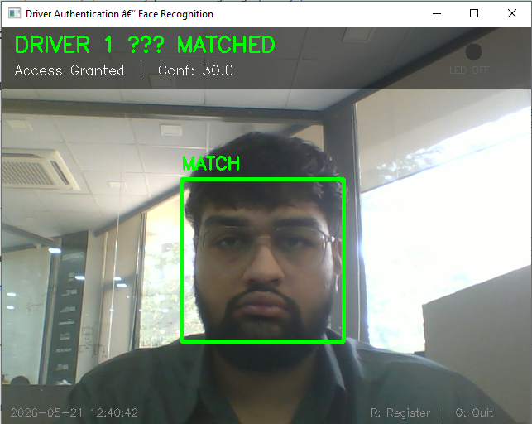  Access granted — green box | 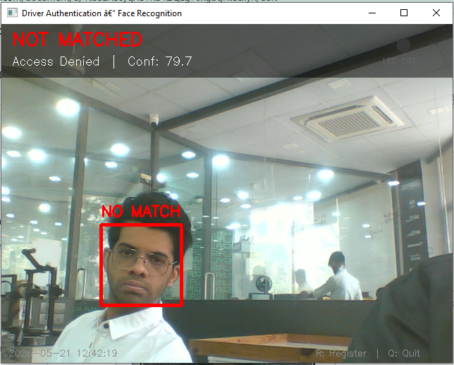  Access denied — red box

6. LED Auto-Lighting & Logging
Brightness is measured in a central ROI; the LED relay debounces with a 5-second confirmation (ON < 60, OFF > 80). All events are logged to auth_log.csv.
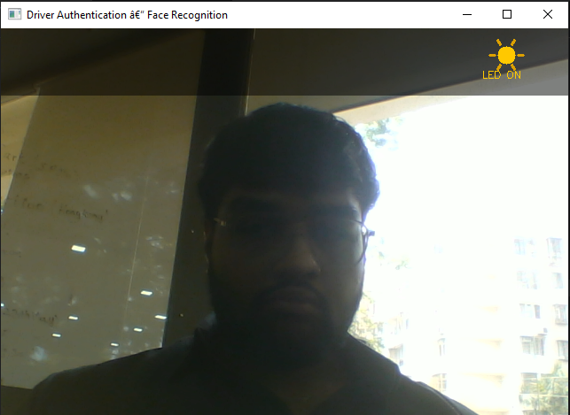  LED ON — low light | 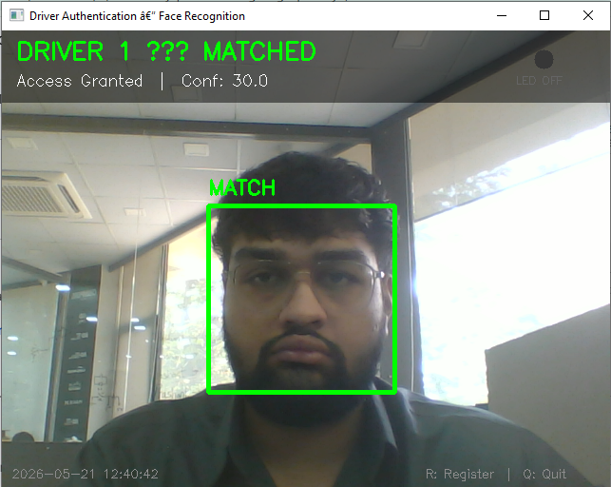  LED OFF — good light
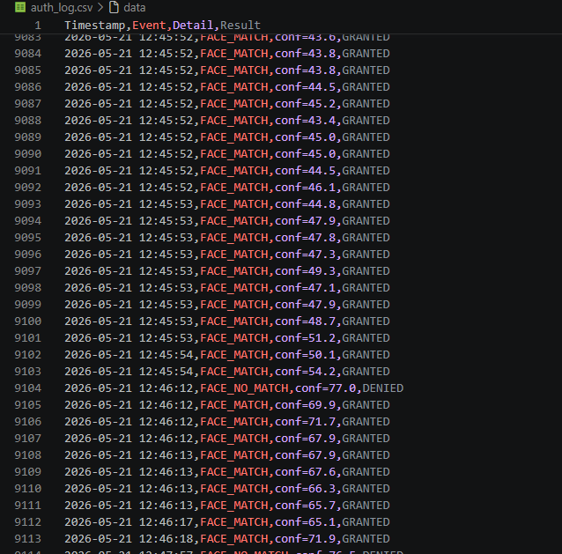
auth_log.csv — timestamped event log
Phase 2

Fingerprint Authentication

1. Overview
Phase 2 adds fingerprint authentication as a second factor. Face recognition is combined with a live R307S optical fingerprint scan, so the vehicle is only authorised when both factors agree.

1.1 Key Features
- R307S over UART (/dev/ttyAMA0, 57600 baud) via pyfingerprint
- Two-scan guided enrollment; on-sensor template at slot #1 with a disk flag
- Dual-factor decision: GRANTED only when face AND fingerprint match
- Scan states WAITING / SCANNING / LIFT / DONE; simulation mode for development

2. Hardware & Wiring
Wire | Signal | Pi Pin
Red / Black | VCC / GND | Pin 4 (5V) / Pin 6 (GND)
Yellow / Green | TXD / RXD | Pin 10 (RX) / Pin 8 (TX)
Blue | TOUCH | Pin 11 (GPIO17, active-low)
White | WAKEUP | Leave floating
Serial Setup
raspi-config → Serial Port: login shell = No, hardware = Yes, reboot. Sensor port /dev/ttyAMA0.

3. Enrollment & Verification
Enroll Once, Verify Forever
The template lives at sensor slot #1 and fingerprint_enrolled.flag is written to disk, surviving restarts.

1 | Place finger on the sensor  First scan into CharBuffer 1
2 | Place the SAME finger again  Second scan confirms the first
3 | Template created and stored  Stored at slot #1; flag saved
result = f.searchTemplate(); slot, score = result[0], result[1]
if slot == -1: return False, conf # no match
confidence = round(min(99.9, score/2.0),1) # MATCH

4. Dual-Factor Decision
final = "GRANTED" if (face_matched and fp_matched) else "DENIED"
Face-Only Auto-Check
A passive auto-check decides on the face alone for presence detection — never to grant ignition. Full authentication always requires both factors.
Phase 3

Relay & Ignition Control

1. Overview
Phase 3 connects the authentication logic to hardware through a 3-channel relay: a timer-latch relay that keeps the Pi powered, the LED relay, and the ignition relay enabled only on a dual-factor GRANTED decision.

2. Relay Channels
Channel | BCM Pin | Polarity | Purpose
Timer Latch | GPIO23 | Active-HIGH | Self-holding power latch energised on boot
LED Light | GPIO27 | Active-LOW | Cabin / sensor lighting (auto-brightness)
Ignition | GPIO22 | Active-HIGH | Ignition enable, gated on GRANTED
Per-Pin Polarity
ACTIVE_LOW_PINS = {PIN_LED_RELAY}; only the LED channel energises on LOW. _set_pin() inverts the level automatically.

3. Timer-Latch Power Hold
The Pi energises GPIO23 on boot; the latch then holds its own supply on, keeping the Pi powered past the external boot-timer window.
def relay_init(): _init_gpio(); timer_latch_on() # GPIO23 HIGH
def relay_shutdown(): ignition_off(); led_relay_off()
# latch left ON; never GPIO.cleanup() (would cut power)
Critical — Never Call GPIO.cleanup()
cleanup() floats GPIO23, de-energising the latch and instantly cutting power. Shutdown releases only ignition + LED.

4. Ignition & LED
Trigger | Action | GPIO22
Full auth → GRANTED | ignition_on() | HIGH
DENIED / auto-check DENIED | ignition_off() | LOW
TURN OFF (remote) | ignition_off() | LOW
The LED auto-lighting now drives the active-low GPIO27 relay, with an SMS LED ON / LED OFF override.
Phase 4

GSM / SMS Remote Control

1. Overview
Phase 4 makes the system remotely operable over the cellular network. A SIM800 GSM module lets the owner control and monitor the vehicle entirely by SMS, and pushes alerts back on every access decision.
Active Hardware Status
The SIM800 is the main open hardware issue: it may not respond to AT commands until a 2.8 V (module) vs 3.3 V (Pi) UART logic-level concern is resolved. See Troubleshooting.

2. Hardware & Architecture
Setting | Value | Notes
Serial port | /dev/ttyAMA2 | UART2 overlay (separate from R307S)
Baud / Mode | 115200 / text | AT+CMGF=1 SMS text mode
Country code | +91 | Prepended to the 10-digit number
A persistent GsmPoller thread holds the port open and polls every 1.5 s; outbound sends use separate short-lived connections so they never block polling.
Why Messages Are Deleted Immediately
Each SMS from AT+CMGL is deleted with AT+CMGD as soon as it is read — SIM slot indices get reused, so a 'seen' set would skip reused slots and fill storage.

3. Command Reference
Command | Effect
AUTH | Run full dual-factor authentication
REGISTER FACE / FP / PHONE | Enroll face / fingerprint / owner number
STATUS / LOG / HELP | Status summary / last 5 logs / command list
TURN OFF | Kill the ignition relay
LED ON / OFF, WAKE UP | Lighting override; wake from sleep
RESET / RESET CONFIRM <pwd> | Begin / confirm a password-protected data reset

4. Troubleshooting (hardware first)
- Logic levels — SIM800 UART ≈2.8 V vs Pi 3.3 V; a level shifter on TX/RX may be needed.
- Power — hold under ~2 A transmit bursts; brownouts drop the module mid-command.
- Signal — AT+CPIN? READY, AT+CSQ not 99, AT+CREG? 0,1 or 0,5. Test/GSM_test.py runs the full sequence.
Phase 5

System Integration & Deployment

1. Overview
Phase 5 ties every subsystem from Phases 1–4 into a single always-on application driven by a state machine and presented as a full-screen kiosk. Main.py is the orchestrator: camera, UI, state, and SMS routing.

2. Architecture & Threading
Module | Role | Phase
FaceDetection / fingerprint_sim | Recognition + fingerprint | 1 / 2
relay_controller / sms_alert | Relays + GSM SMS | 3 / 4
logger / first_boot | Logs + setup wizard | 1–5 / 5
Main.py | State machine, UI, lifecycle, dispatch | 5
The main thread runs the render loop, state machine, and SMS handling (all shared-state mutation here); workers and the GsmPoller run in the background.

3. State Machine
State | Meaning
IDLE / SLEEPING | Live preview / dimmed after inactivity (SMS still active)
FIRST_BOOT | Guided setup wizard over SMS
REG_FACE / REG_FP | Registration / enrollment in progress
AUTHING / RESULT | Authentication running / showing the outcome
RESETTING | Data reset being executed

4. First-Boot, Kiosk & Lifecycle
Setup Step | Required? | Completed By
password / face / fingerprint | Required | SET PASSWORD / REGISTER FACE / REGISTER FP
phone | Optional | REGISTER PHONE <num>
The UI is one full-screen OpenCV window, display-only, auto-detecting the GTK/Wayland/X11 backend. On boot relay_init() energises the timer latch; on exit relay_shutdown() releases ignition + LED but leaves the latch ON.
Power-Safe Lifecycle
The timer latch is energised first on boot and left on through shutdown, guaranteeing stable power for the entire run.

pip install opencv-contrib-python numpy picamera2 \
pyfingerprint pyserial RPi.GPIO --break-system-packages
python3 Main.py
The in-app kiosk is implemented; OS-level autostart at session start (Wayland/labwc) is the final commissioning step.

With Phase 5 the system is functionally complete: a single Raspberry Pi unit that recognises a driver's face and fingerprint, gates ignition through a relay, holds its own power, and is fully operable by SMS — an unattended full-screen kiosk documented end to end across the five phases.

